**Biodiversity and dynamics of Desmidiales (Zygnematophyceae) in mangrove waters of the Cameroon estuary: influence of some abiotic factors**

**Eric Joselly Kouedeum Kueppo, Rodrigue Nanfack Dongmo, Janvier Kengne Tenkeu, Pascal Banga Medjo, Serge Hubert Zebaze Togouet\***

Laboratory of General Biology, Faculty of Science, University of Yaounde I, Yaounde, Cameroon

Corresponding author (*): Yaounde, Cameroon,

Email: [*ztsh2004@yahoo.fr;](mailto:*ztsh2004@yahoo.fr) [*zebasehu@yahoo.fr](mailto:*zebasehu@yahoo.fr)

|  |  |
| --- | --- |
| **Article Info** | **Abstract** |
| Volume5, Issue1, Jan 2023  Received:23 November 2022  Accepted :13 December 2022  Published: 13 Jan 2023  *doi: 10.33472/AFJBS.5.1.2023.37-55* | Desmidiales are influenced by the physicochemical quality of the waters of the estuary mangroves which are very sensitive and increasingly threatened ecosystems. This study analyzed the waters of the mangroves of the Cameroon estuary and evaluated the influence of the abiotic factors on the diversity and dynamics of Desmidiales. Samples for physicochemical and biological analysis were collected monthly in 9 stations over a period from November 2019 to November 2020 according to standard methods. High temperature levels (28.73 ± 1.6°C), salinity varying from fresh (0.012 ‰) to salt water (14.6 ‰) and medium oxygenation indicate (66.23 ± 16.46 %) a moderately polluted environment. A total of 61 species belonging to the order of Desmidiales, families of Closteriaceae and Desmidiaceae, and belonging to 09 genera of which *Staurastrum*, *Closterium*, *Cosmarium*, *Spondylosium*, *Staurodesmus*, *Xanthidium*, *Euastrum*, *Micrasterias* and *Pleurotaenium* were identified for a total density of 18784 ind/L. Theanalysis shows that the high biological diversities (34 to 43 species) and densities (2.83 ind./L to 11835 ind./L) coincide with the stations of the fluvial estuary who were characterized by a salinity lower than 1‰. Desmidiales could be used as indicator of the ecological status of waters and to evaluate the impact of tidal movements. |
| **Key words:** Desmidiales, Cameroon Estuary, dynamic, Mangroves, Physicochemistry. |
| © 2023 Eric Joselly Kouedeum Kueppo, This is an open access article under the CC BY license (https://creativecommons.org/licenses/by/4.0/), which permits unrestricted use, distribution, and reproduction in any medium, provided you give appropriate credit to the original author(s) and the source, provide a link to the Creative Commons license, and indicate if changes were made |

**1. Introduction**

In the tropics, mangroves represent 60% to 75% of coastal vegetation (Por and Dor, 1984). Present in Cameroon in the areas of the Rio Del Rey estuary, the Cameroon estuary and the mouth of the Nyong, Lekoundjé and Ntem rivers; these mangroves, which cover an area of about 2,749 km2 (Envi-Rep Cameroon, 2018), are victims of anthropogenic degradations.

Thus, nearly 70,000 hectares of these important carbon storage sinks were radically destroyed between 1980 and 2006 in Cameroon (UNEP, 2007). These mangroves nutritional, ecotourism and health benefits, but also a spawning area for a multitude of aquatic species for which phytoplankton serve as food. This phytoplankton also plays an important role in the maintenance of the food web with more than 45% of the primary production on Earth (Behrenfeld *et al.,* 2005) and the order of Desmidiales is of fundamental importance both from the nutritional and ecological points of view (Bourrelly, 1990). They are excellent biological indicators of the quality of aquatic environments and like the Diatomophyceae, they are very sensitive to temperature, variations in the chemical composition of water (Bourrelly, 1990) and contribute to about 70% of the total number of species in the Class Zygnematophyceae (Gontcharov and Melkonian, 2005). They are usually unicellular organisms, without defined shape, and rarely in colony form (Acleto and Zúñiga, 1998; and Yinxin and Minjuan, 2005), having a median constriction called isthmus, which divides the cells into two equal halves, called semi-cells (Oliveira, 2008; and Felisberto and Rodrigues 2013). They are distributed in a cosmopolitan way and numerous in freshwater environments such as oligotrophic and mesotrophic lakes, ponds and rivers (Wehr and Sheat 2003).

In Cameroon, phytoplankton studies within the mangroves of the Cameroonian coast are still poorly explored. A review of the literature reveals that almost all the work carried out has focused on the macroflora, forgetting to take into account the aquatic microflora. The few studies carried out by Folack (1989), Fonge *et al.* (2015) and Motto *et al.* (2020) focused on the coastal of Kribi and Limbe, forgetting the Cameroon estuary. This study therefore aims at evaluating the physicochemical quality of mangrove waters and the distribution of Desmidiales in order to highlight the impact of abiotic factors on their diversity and dynamics in a part of the Cameroon estuary influenced by the waters of the Atlantic Ocean.

1. **Materials and methods**

**Study site**

This study was conducted in the mangroves of the Cameroon estuary, Littoral Region, in the districts of Mouanko and Douala VI, departments of the Sanaga Maritime and Wouri respectively (**Figure 1**). The hydrographic network of this area is watered by the Sanaga, Kwakwa, Dibamba and Wouri rivers. Geologically, the soil is hydromorphic mineral and stands on a metamorphic base geological complex of Precambrian age (Nzolang *et al.*, 2003). The climate is equatorial and monomodal with two seasons, a short dry season from mid-November to February and a long rainy season from March to mid-November (Sighomnou, 2004). The thermal regime is hot (27°C ± 6.9°C), and an annual rainfall of about 4513 mm (Sighomnou, 2004). 09 sampling stations were selected according to the type of mangrove forest, the three parts of the estuary profile (Wiley and Chichester, 1980) and anthropogenic activities (**Figure 1**). Stations D1 and D2 located at the mouth of the Sanaga river are in a regenerating mangrove. Stations D3, E1, E2, and E3 are located in a little anthropized area and are dominated by plants of the genus *Rhizophora*. Station S1 dominated by the species *Avicennia germinans* and the Station S2 dominated by the species *Nypa fructicans* arelocated in a highly anthropized zone; unlike station S3 which is dominated by the fern plant *Acrusticum aurerium.*

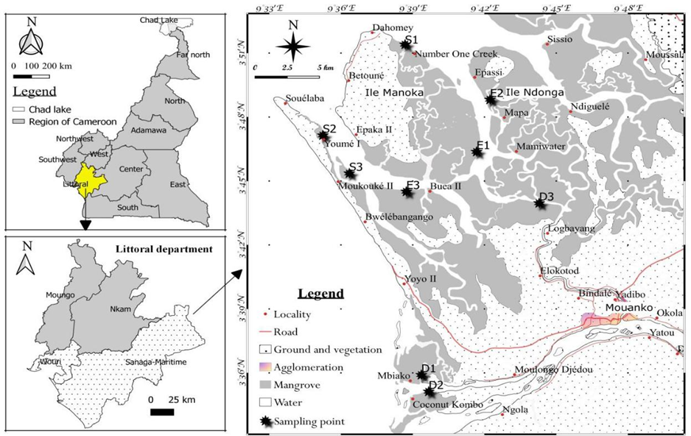

**Figure 1:** Map of a part of the mangroves in Cameroon estuary showing the sampling stations

**Data collection**

Physicochemical and biological data were collected between the surface and 0.5 m depth from November 2019 to November 2020 at a monthly frequency by using an outboard canoe equipped with a 40-horsepower motor to travel to all sampling stations. The water was then collected without bubbles using polyethylene vials with double caps and stored in a refrigerated chamber (4°C). Phytoplankton organisms were collected by filtering 30 L of water through a 20 µm mesh-size plankton filter and concentrated into 100 mL. On one hand, part of this sample was fixed with lugol (5%) and then kept in the dark (Bourrelly, 1985), while on the other hand, part was kept unfixed in order to identify motile, flagellated or ciliated species that would be rendered unrecognizable by the fixative

**Physicochemical parameters**

Physicochemical variables were measured using appropriate equipment and following the techniques and recommendations of ALPHA (1998) and Rodier *et al.* (2009). In the field, dissolved oxygen was measured using the HACH HQ30d flexi oximeter, while water temperature, pH, salinity and electrical conductivity were measured using the LAQUA Horiba P200 multi-parameter. In the laboratory, Suspended Solids (SS), turbidity, nitrates and orthophosphates were measured using colorimetric method with the HACH/DR 2010 spectrophotometer, while alkalinity was measured using volumetric method.

**Biological variables**

The Lorenzen colorimetric method (Lorenzen, 1967) with a volume of 200-500 mL of filtered water sample was used for the measurement of chlorophyll 'a' and pheopigment. After 48 hours of sedimentation, the supernatant was gently removed and the remainder is stored in 5 ml container. Subsequently, 1 ml of the previously homogenized sample was pipetted and observed in a Sedgewick-Rafter counting cell using the Utermöhl (1958) method. The identification and counting of phytoplanktonic species were carried out at 100X and 200X magnification using an Ivymen Optic microscope equipped with a OMAX A3503S Camera digital microscope to allow easier identification, using the specific works of Ouattara (2000); Dellamano-Oliveira *et al.* (2008); Komoe (2010); Oliveira *et al.* (2011); Felisberto and Rodrigues (2013); Bicudo *et al.* (2014); Santos *et al.* (2014) and Aquino *et al.* (2017).

**3. Statistics Analysis**

The biological data obtained were used to determine density, frequency of occurrence and diversity indices to refine the structure of the Desmidiales of the mangroves of the Cameroon estuary.

* Density of organisms (D in ind./L) represents the number of individuals (N) per unit volume (V) and was calculated by the formula: **D = N/V**
* Frequency of occurrence (F in %) provides information on the constancy of a species or taxon in a given habitat without any indication of its quantitative importance (Dajoz, 2000). It is calculated by the equation: **F = (Na/N) ×100**
* With **Na** = number of records containing the species and **N** = total number of samples taken. The key of Dufrêne and Legendre (1997) was used to classify species into: Omnipresent (F=100%), regular (75≤F<100%), constant (50 ≤F<75%), accessory (25≤F<50%) and rare (less than 25%).
* Shannon and Weaver (1963) diversity index (H’), which reflects the diversity present at the different stations, was calculated using the formula: **H' =-Σ[(ni/N) × log2(ni/N)]** with **H'** = represents the specific diversity in bits/index; **ni** = the number of individuals of species i; **N**=total number of individuals considering all species and **log2** =logarithm in base
* It varies 0 (only one species or a species dominating all other very extensively) to S log (all species even have abundance)
* Pielou (1966) equitability index (J) allowed us to evaluate the equal-representation of species in relation to a theoretical equal distribution for all species. It is obtained by the formula: **J = H' / log2 S** with **H’**= Shannon and Weaver index; **S** = number of species present. This index (J) varies from 0 (when only one taxon dominates) to 1 (when all taxon have the same abundance).
* Sörensen’s similarity index (Cs) was used to evaluate the similarity of the algal flora between the different stations. Its mathematical expression is: **Cs = (100 x 2c)/ (a + b)** with **Cs** = coefficient of similarity; **a** = number of species from station 1; **b** = number of species from station 2; **c** = number of species common to the two stations. The values of Cs vary between 0 and 100%. The more common the species are between the two stations, the more Cs tends towards 100% and the more different the species are between the two stations, more the Cs value tends towards 0%.

Principal Component Analysis (PCA) was applied to the physicochemical variables and to the composition of the population in order to group the sampling stations according to their biotic or abiotic similarities. These analyses were carried out with the R software version 4.0.5.

**3. Results**

**Physicochemical parameters**

The physicochemical analysis obtained during the study revealed that the temperature of the water varied in the fluvial estuary from 25.8 to 32°C; in the intermediate estuary from 25.4 to 30.5°C and in the marine estuary from 26.4 to 32°C for an overall average of 28.72

* 1.59°C. (**Figure 2A**). A significant difference was recorded between the intermediate and marine estuaries (P=0.003). The pH values ranged from 5.85 to 9.37 CU in the fluvial estuary, from 6.19 to 9.05 CU in the intermediate estuary and from 6.45 to 8.59 CU in the marine estuary (**Figure 2B**). Globally, the mangrove waters are weakly basic with an overall average of 7.63 ± 0.63 CU.

The variations of salinity (**Figure 2C**), with an overall average of up to 4.3‰, and electrical conductivity (**Figure 2D**), with an overall average of up to 7.56 mS/cm, follow the same profile. In the fluvial estuary they ranged from 0.012 to 0.7 ‰, and from 0.013 to 1.36 mS/cm for salinity and electrical conductivity values respectively. In the intermediate estuary, salinity fluctuated between 0.1 and 10.04 ‰ while electrical conductivity fluctuated between 0.22 and 1.78 mS/cm. Finally in the marine estuary salinity varied from 1.13 to 14.6 ‰ and electrical conductivity from 1.47 to 24.9 mS/cm. Significant variations (P≤0.001) were obtained between the fluvial and intermediate estuaries and between the fluvial and marine estuaries. Spearman's correlation test shows a strong positive correlation between these two variables at the 0.01 threshold (r=0.98).

The variation profile of Suspended Solids (SS) was similar to that of turbidity, with a positive and significant correlation r=5.4 at the 0.01 threshold. The SS ranged from 1 mg/L to 54 mg/L, 74 mg/L and 78 mg/L, in the fluvial, intermediate and marine estuaries, respectively, with an overall average of 12.86 ± 13.19 mg/L (**Figure 2E**). Turbidity ranged from 1 FTU to 98 FTU, 110 FTU, and 155 FTU in the intermediate, fluvial and marine estuaries respectively, with an overall average of 25.43 ± 25.19 FTU (**Figure 2F**). Both variables varied significantly from fluvial to intermediate estuaries and from fluvial to marine estuaries (P˂0.001). 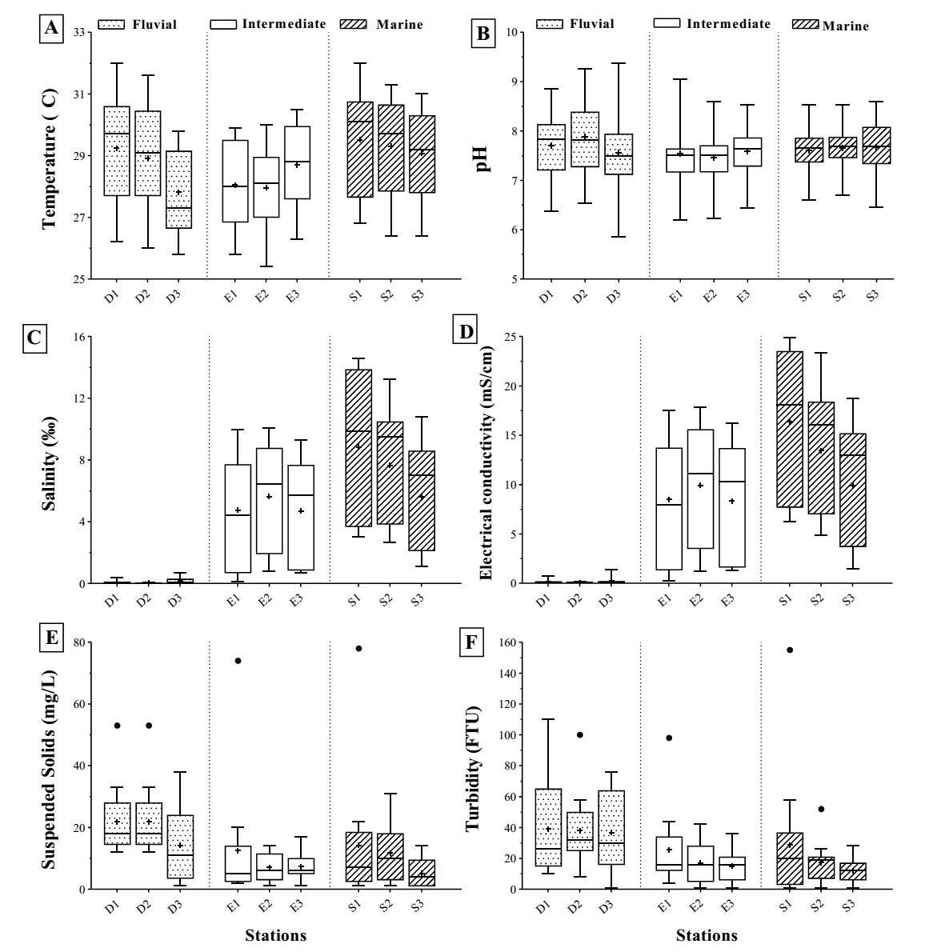

**Figure 2:** Spatial variations of temperature (A), pH (B), Salinity (C), Electric conductivity (D), Suspended Solids (E) and turbidity (B) during the study period

Dissolved Oxygen (DO) showed a wide range of variation from 8.3 to 97.6% in the fluvial estuary, from 35 to 81.6% in the intermediate estuary and from 29.4 to 88% in the marine estuary with an overall average of 66.23 ± 16.46% **(Figure 3A)** and a significant difference between the fluvial and intermediate estuaries (P=0.002). Alkalinity with an overall average of 6.9 ± 4.12 mg/L **(Figure 3B)** varied from 2 to 16 mg/L in the fluvial and intermediate estuaries and from 2 to 30 mg/L in the marine estuary with a significant difference and between the fluvial and marine estuaries (P=0.037).

The nitrate values were relatively high with an overall average of 6.71 ± 3.5 mg/L. The fluvial estuary fluctuated between 1.18 and 14.4 mg/L, the intermediate estuary between 1.84 and 15.2 mg/L and the marine estuary between 0.9 and 16.4 mg/L **(Figure 3C).**

Orthophosphate levels ranged from 0 to 0.62 mg/L, 0 to 0.84 mg/L and 0 to 0.91 mg/L for the intermediate, fluvial and marine estuaries respectively, with an overall average of up to 0.16 mg/L **(Figure 3D)**.

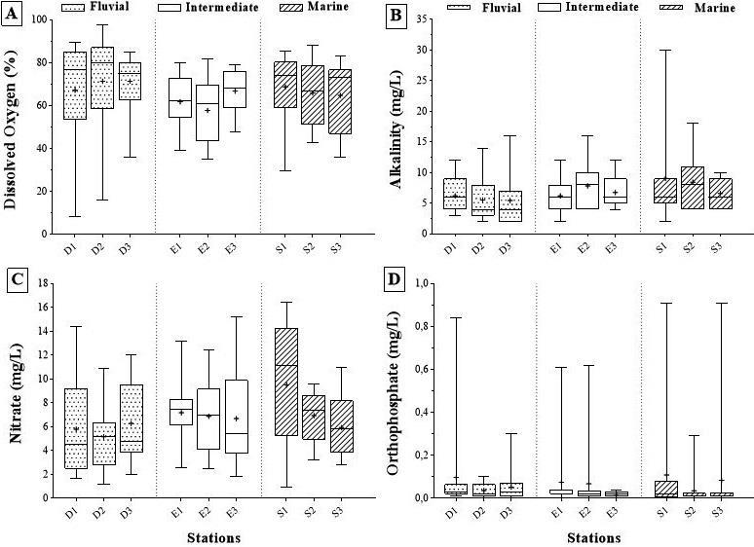

**Figure 3:** Spatial variations of dissolved oxygen (A), Alkalinity (B), Nitrates (A) and orthophosphates (B) during the study period

**Biological parameters**

**Chlorophyll a and pheopigment**

Chlorophyll a (Chla) and pheopigment (Phg) did not vary significantly between different parts of the estuary. Chla ranged from 1.07 and 1.26 to 135.69 µg/L in the fluvial and intermediate estuaries respectively and from 0.64 to 124.35 µg/L in the marine estuary for an overall average of up to 27.92 µg/L (**Figure 4A**). As for Phg with a general average of up to 21.04 µg/L; the fluvial, intermediate and marine estuaries varied from 1 to 48.45 µg/L; from 1.28 to 159.45 µg/L and from 1.31 to 91.58 µg/L respectively (**Figure 4B**).

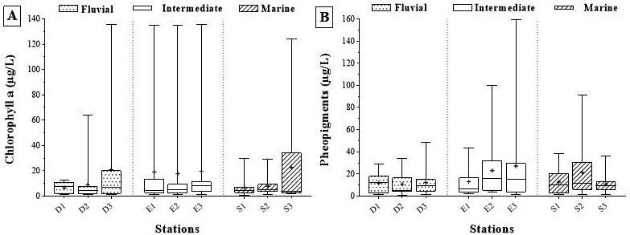

**Figure 4:** Spatial variations of Chlorophyll ‘a’ (A) and (B) pheopigment during the study period

**Phytoplankton**

**Diversity of the Desmidiales**

During this study, 61 phytoplankton species were identified (**Table 1**). All belonging to the class of Zygnematophyceae, order of Desmidiales, families of Closteriaceae and Desmidiaceae, and to 09 genera (**Table 1**). The most diverse genera were *Staurastrum* (26 species) followed by *Closterium* (12 species), *Cosmarium* (9 species), *Staurodesmus* (4 species), *Spondylosium* (4 species) and *Xanthidium* (3 species). The genera *Euastrum*, *Micrasterias* and *Pleurotaenium* were mono-specific. Station D3 (43 species) was the mostdiverse, followed by station D1 (39 species) and D2 (34 species). Stations S1 and S2 were the least diverse with 3 species each while stations S3, E1, E2, E3 had 8 species, 14 species, 8 species and 6 species respectively. The calculated percentage of occurrence allowed us to determine the taxa according to their frequency of occurrence in the ecosystem (**Table 1**). 04 species were constant in stations. These were *Closterium kuetzingii* (station D3), *Staurastrum elongatum* (station D1) *S. leptocladum* (station D3) and *S.* sp. (station D2). Therest of the species are classified as rare except for *Closterium aciculare* (stations D1 and D2*), C. acutum var. linea* (station D2), *C. gracile* (station D1), *Staurastrum elongatum* (station D2), *S. inflexum* (station D3), *S. longipes* (stations D1 and D2), *S. polymorhum* (stations D1), *S.* sp1. (station D3), *S. sebaldi* (stations D2 and D3), *S. subgracillimum* (stations D1 and D2), *S. tetracerum* (stations D1 and D3), *S. tohopekaligense* (station D3) and *S. volans* (station D1) which were accessory.

Table 1: Desmidiales identified during the study period

|  |  |  |  |  |  |  |  |  |  |  |  |
| --- | --- | --- | --- | --- | --- | --- | --- | --- | --- | --- | --- |
| Taxonomie | D1 | D2 | D3 | E1 | E2 | E3 | S1 | S2 | S3 | Ft | TD |
| Ordre: Desmidiales |  |  |  |  |  |  |  |  |  |  |  |
| 1. Famille: Closteriaceae Bessey, 1907 |  |  |  |  |  |  |  |  |  |  |  |
| Genre: *Closterium* Nitzsch ex Ralfs, 1848 | | |  |  |  |  |  |  |  |  |  |
| *C. aciculare* West, 1860 | xx | xx | x |  |  |  |  |  | x | 13.31 | 199 |
| *C. acutum var. linea* Brébisson, 1848 | x | xx | x | x |  | x |  |  | x | 10.26 | 137 |
| *C. Cynthia* De Notaris, 1867 | x |  |  |  |  |  |  |  |  | 7.69 | 126 |
| *C. diane* Ehrenberg ex Ralfs, 1848 | x | x |  |  |  |  |  |  |  | 15.38 | 127 |

x=0%˂ **F**˂25%; xx= 25%≤ **F**˂50%; xxx= 50% ≤ **F**˂75%; xxxx= 75%≤ **F** ˂100%; xxxxx=**F** = 100% **F** = occurrence Frequency **(%) Ft** = Total occurrence Frequency **(%)**; **TD** = Total Density

**(ind./L)**

The density of phytoplankton recorded in the different stations fluctuated between 9 ind./L and 11835 ind./L with a total density of 18784 ind./L (**Figure 5**). The stations of the fluvial estuary D1 (3839 ind./L), D2 (2825 ind./L) and D3 (11835 ind./L) presented the highest densities (98%) while the stations of the intermediate E1 (120 ind./L), E2 (78 ind./L), E3 (21 ind./L) and marine estuary, S1 (9 ind./L), S2 (18 ind./L) and S3 (39 ind./L) were slightly dense (1.17% and 0.35% respectively). This density of Desmidiales in the fluvial estuary varied significantly between the fluvial estuary and the intermediate and marine estuaries (P˂0.001).

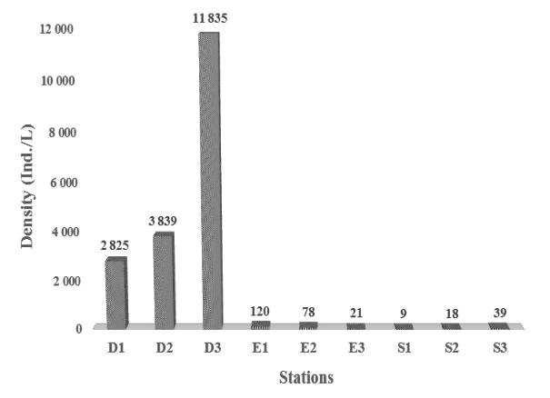

**Figure 5:** Density variation in the study stations

**Structure of the algal population**

On the 09 genera identified, *Staurastrum* (74.17%) with species *S. leptocladu*m (2344 ind./L) and *Spondylosium* (25.38%) with species *S. secendeus* (891 ind./L) were the most abundant (**Figure 6A**). Similarly, the genera *Micrasterias* (0.02%), *Pleurotaenium* (0.04%) and *Xanthidium* (0.07%) were the least abundant and the species *Xanthidium octocorne* waspoorly represented with a density of 1 ind./L in the station D1.

The spatial variation of the Shannon and Weaver diversity index (H’) and Pielou regularity index (J) in the stations show the lowest values of the H’ index at stations S1 (1.44 bits/index) and S2 (1.35 bits/ind.) in the marine estuary, while the highest were recorded at stations D1 (4.13 bits/index), D2 (3.43 bits/ind.) and D3 (3.83 bits/ind.) in the fluvial estuary (**Figure 6B**). The station S3 (2.81 bits/index) and the stations in the intermediate estuary E1 (3.14 bits/index), E2 (2.45 bits/ind.) and E3 (2.33 bits/ind.) showed intermediate values. All this reflects a low diversity of species (2.14 ± 0.98 bits/ind.). The J index varied from 0.67 to 0.93, reflecting a tendency for individuals of the different species to be equally distributed among the different stations.

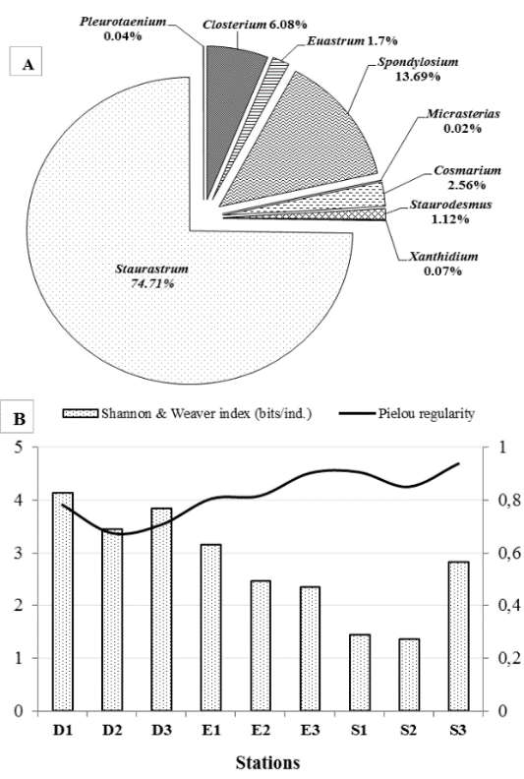

**Figure 6:** Density of genera (A), and spatial variation of Shannon-Weaver index and Pielou regularity (B) in the study stations

The values of the degree of similarity between the different stations ranged from 0% to 100% (Table 2). The highest value (100%) was obtained between stations S1 and S2, and the lowest (0%) was obtained between stations S1 and E3 on the one hand and S2 and E3 on the other hand. This similarity is higher between the stations in the fluvial estuary compared to the intermediate and marine estuaries with an average of 66.67%, 50.73%, and 45.47% respectively.

**Table 2:** Sörensen’s similarity coefficients (%) calculated between the different stations

|  |  |  |  |  |  |  |  |  |
| --- | --- | --- | --- | --- | --- | --- | --- | --- |
| Stations | D1 | D2 | D3 | E1 | E2 | E3 | S1 | S2 |
| D2 | 68,5 |  |  |  |  |  |  |  |
| D3 | 75,6 | 64,9 |  |  |  |  |  |  |
| E1 | 44,4 | 44,9 | 34,5 |  |  |  |  |  |
| E2 | 29,8 | 38,1 | 27,5 | 52,2 |  |  |  |  |
| E3 | 22,2 | 25 | 20,4 | 57,1 | 42,9 |  |  |  |
| S1 | 9,5 | 10,8 | 13 | 22,2 | 36,4 | 0 |  |  |
| S2 | 9,5 | 10,8 | 13 | 22,2 | 36,4 | 0 | 100 |  |
| S3 | 34 | 38,1 | 31,4 | 43,5 | 37,5 | 14,3 | 18,2 | 18,2 |

**Principal Component Analysis of abiotic and biotic variables**

The Principal Component Analysis (PCA) shows the existence of three blocks for the abiotic variables and two blocks for the biotic variables. The two dimensions that characterize the physicochemical parameters explain 74.3% of the variables (**Figure 7A**). pH, Suspend Solid, Dissolved Oxygen and Turbidity were negatively correlated to dimension 1 (50.7%) and group the stations of the fluvial estuary D1, D2, and D3 to form unit 1. Nitrates, Alkalinity, Salinity and Electrical Conductivity were positively correlated to dimension 1 and group the stations of the marine estuary S1, and S2 to form unit 2; but, negatively correlated to dimension 2 and group the stations S3, E1, E2, and E3 to form unit 3.

For the biotic PCA, the 2 dimensions explain 88.4% of the species (**Figure 7B**). Here, almost all species are positively correlated to dimension 1 (51.3%) which groups the fluvial estuary stations D1, D2, and D3 to form unit 1 and contrasts it with the rest of the stations (unit 2). The high salinity and electrical conductivity levels recorded in the stations of intermediate and marine estuaries coincide with the low phytoplankton diversity and density recorded.

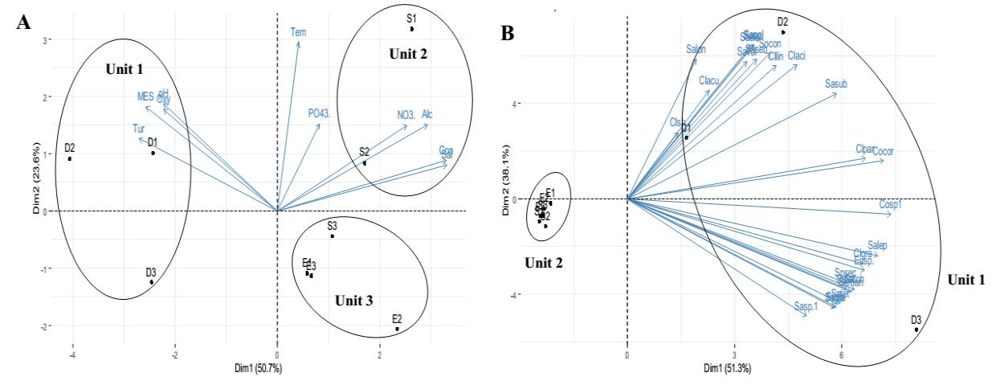

**Figure 7:** Principal Component Analysis of abiotic (A) and biotic (B) variables of mangroves stations in the Cameroon estuary

**4. Discussion**

**Physicochemical parameters**

The high general average water temperature in the study area is characteristic of a tropical coastal zone (Sighomnou, 2004). The high-water temperature values recorded at the stations D1 and S1 are the result of the reduction in canopy cover and thus allowing the water to follow the ambient thermal evolution as highlighted by Liechti *et al.* (2004). The slightly acidic to basic pH observed at stations in the Cameroon estuary is characteristic of environments that dilute fresh and salt water, but also of the bedrock that drains the water of the rivers. These results are close to those obtained in a part of the Douala estuary (Fonge *et al.,* 2013). Such temperature and pH values are favorable for the development of green microalgae, which have a strong affinity for environments with high pH and temperature (Assougnon *et al.,* 2017).

The intrusion of water from the Atlantic Ocean loaded with mineral elements and its mixing with fresh water from the continent, translates the profile of the Cameroon estuary (Wiley and Chichester, 1980; Foussard and Etcheber, 2011). The dominant influence of salt water on stations S1, S2 and S3 would justify the high salinity and electrical conductivity values recorded (high than 1 ‰ and 1.5 mS/cm respectively). The stations E1, E2 and E3 are depending on the size of the tides, weakly or strongly impacted allowing salinity and electrical conductivity to vary respectively from 0 to more than 1 ‰ or ˂1 mS/cm. Atlantic Ocean water would increase salinity, electrical conductivity and alkalinity, hence the strong positive correlations between these variables r =0.98, r =0.36 and r =0.34 (P=0.01). On the bare hand, the weak tidal action on stations D1, D2 and D3 would be at the origin of the low values of salinity, electrical conductivity obtained (lower than 1 ‰ and 1.4 mS/cm respectively).

As for the relatively low average SS content, it would be due to the lentic state of the water within the mangroves, which favors particle decantation. Moisan and Pelletier (2008) mention in this respect that suspended matter is likely to settle at calm points. The sedimentation of Suspended Solids would therefore explain the low turbidity values recorded in the intermediate and marine estuaries, hence the positive correlation between these 2 variables (r=0.54; p=0.01). Nevertheless, the high levels recorded at the stations in the intermediate (E3) and marine (S1) estuaries compared to the fluvial estuary would be the result of the combined action of the waste from the Atlantic Ocean and the catchment areas carrying the waste during rainy episodes (Al-Aubadi *et al.;* 2019). These results are similar to those obtained by Dikoume *et al.* (2016) in the lower catchments of the Sanaga river.

With regards to Dissolved Oxygen, the high variation in values obtained are similar to those observed by Hilaluddin *et al.* (2020) in the mangroves of the Malaysian estuary. The low values in the stations D1 and D2 are believed to be the result of the presence of a high load of reducing matter, particularly organic matter (Billen *et al.,* 1999) from the Sanaga river. Similarly, the high values recorded correspond to the months of the rainy season. These values characterize a high photosynthetic activity for the microalgae (Ramade, 2005) and thus translate a high productivity of the phytoplanktonic biomass represented by the high chlorophyll and pheopigment values during the whole study period (Lu *et al.,* 2016). The physicochemical quality of the water varied from the fluvial estuary to the intermediate and marine estuaries, but remained low in pollution at all stations.

**Structure and dynamic of Desmidiales**

The 61 species recorded indicate a clearly diversified Desmidiales population in the Cameroon estuary. This species richness is high compared to the 24 species recorded in the mangroves of Cameroon in 2017 (MINEPDED-CRM 2017) and the 16 species recorded by Santos *et al.* (2014) in the Bateias lagoon in Brazil. This difference can be explained by the sampling effort but also by the fact that the lagoon is not very diverse (Santos *et al,.* 2014). The great diversity of microhabitats offered by rivers and forests in Amazonia, in contrast to mangroves, allowed Mouhri *et al.* (1990) and Lopes and Bicudo (2003) to obtain a higher specific diversity of 133 species and 98 species respectively.

The distribution of prokaryotic and eukaryotic organisms is strongly coupled to physicochemical variables (Haralambidou *et al.,* 2010), including salinity. Salinity stress would therefore lead to the modification of vital functions such as photosynthesis and amino acid synthesis (Kawasaki *et al.,* 2001; Ozturk *et al.,* 2002 and Seki *et al.,* 2002). Thus, of the 70 species identified in the coastal saltwater of Kuantan, Pahang, Malaysia by Mohammad-Noor *et al*. (2013), no Desmidiales species were collected. The results of this study indicate a reduction in diversity and density of Desmidiales as salinity and electrical conductivity increased; hence the negative correlation (p=0.05 and p=0.01) recorded with 31 of the species that disappear when salinity and electrical conductivity increase. High levels of these variables therefore have a negative effect on microorganisms (Wutipraditkul *et al.,* 2005), including Desmidiales. The introduction of Atlantic Ocean saltwater in thestations of intermediate and marine estuaries would lead to a decrease in the diversity of Desmidiales in this part of the Cameroon estuary. The salty oceanic water would thus play a regulating role in the composition of species (Desmidiales) and biomass, and consequently in water quality (Haralambidou *et al.,* 2010 and Zhou *et al.,* 2016). In contrast, the high values of diversity and density obtained in the stations of fluvial estuary suggest a low impact of salinity and electrical conductivity on these organisms. However, driven by the river current, the presence of species such as *Closterium acutum*, *Staurastrum elongatum*, *S. leptocladum*, *S. longipes*, *S. sebaldi*, *S. tetracerum* and S*. volans* within the stations locatedin intermediate and marine estuaries with their low density and Shannon and Weaver diversity indices, would reflect a certain limited tolerance to salinity and electrical conductivity; as well as a survival strategy based on sexual reproduction with the formation of zygotes able to resist to the periods of stress.

The density of the phytoplanktonic population recorded was much lower than the 500 to 162,000 Cell/L collected by Mouhri *et al.* (1990). This could be explained by the lack of sampling on substrate which is also a preferred habitat for Desmidiales (Mouhri *et al.,* 1990); but also by the increasingly stressed environment due to the decrease in Dissolved Oxygen levels, the ever-increasing increase in mineral elements and the impact of Salinity and Conductivity in some stations. Furthermore, the abundance and dominance of species of the genus *Staurastrum* is justified by the fact that it commonly represents 20-30 % of the Desmidiales species (Bicudo and Menezes, 2006 and Gontcharov, 2008). These results are similar to those obtained by Dellamano-Oliveira *et al.* (2008) and Santos *et al*. (2014), and the 26 species obtained is close to the 21 species collected by Felisberto and Rodrigues (2013). All this would reflect a capacity for growth and reproduction adapted to environments with limited food resources; in contrast to species of the genus *Micrasterias* characterized by oligotrophic water (Coesel, 1983). Consequently, the diversity and dynamics of Desmidiales in the different zones of the mangrove of the Cameroon estuary are strongly impacted by abiotic riverine and oceanic variables.

**5. Conclusion**

Subject to deforestation, abusive fishing, pollutants from the watersheds and tidal movements, the hydrobiological study of some mangroves of the Cameroon estuary revealed that its waters are moderately oxygenated, very turbid, rich in Suspended Solids and nitrates, with a low basic pH and high temperatures. Due to the influence of tidal movements, part of the mangroves is impacted by salty water from the Atlantic Ocean. The biological analysis revealed the presence of 61 species of Desmidiales (Zygnematophyceae) dominated by the Desmidiaceae family and species of the genus *Staurastrum*, of which *S. leptocladum* was the most abundant. Stations located in the freshwater estuary showed ahigh specific richness and abundance in contrast to those located in the transitional and saltwater zones. The strong negative correlation between almost all species and the stations in the transitional and saline zones highlights the impact of the salinity and electrical conductivity concentrations recorded on the dynamics of the Desmidiales. The increase in the salinity of mangrove waters would lead to the disappearance of Desmidiales, thus characterizing them as a freshwater phytoplanktonic group. The fight to safeguard this coastal ecosystem should be stepped up while taking into account the impact of all anthropic activities in the catchment areas and abiotic variables on biological diversity in order to achieve sustainable biomonitoring.

**References**

Acleto, C. and Zúñiga, R. (1998). Introduction to Algae. Escuela Nueva Publishnig house S A., Lima. Peru. 383 p.

Al-Aubadi, I.M.K., Alabadi, L.A.S., Hashim, L.Q. and AlHadithi, A.H. (2019). Use simple alternative method for estimating water turbidity. Plant archives, 19, 598-601.

APHA. (1998). Standard method for examination of water and wastewater. American Public Health Association, 20th edition, Washington, DC, 1150p.

Aquino, N., Camila, A., Bueno, N.C., Servat, L.C. and Bortolini, J.C. (2017). The genus Euastrum Ehrenberg ex Ralfs (Desmidiaceae) in a subtropical stream adjacent to the Parque Nacional do Iguaçu, Paraná State, Brazil. Hoehnea, 44, 1-9.

Assougnon, D.L., Agadjihouèdé, H., Kokou, K. and Lalèyè, A.P. (2017). Physico-chemical characterization and diversity of phytoplankton population of ponds in the south of Togodo Wildlife Reserve (South Togo). International Journal of Biological and Chemical Sciences, 11, 1920-1936.

Behrenfeld, M.J., Boss, E., Siegel, D.A. and Shea, D.M. (2005). Carbon-based ocean productivity and phytoplankton physiology from space, Global Biogeochemical cycles, 19, GB1006.

Bicudo, C.E.M. and Menezes, M. (2006). Genera of algae from continental water in Brazil: key to identification and descriptions, 2nd edition. Rima Edition, São Carlos, 502 p.

Bicudo, C.E.M., Schettt, S.P. and Castro, A.A.J. (2014). Physiological flora of the state of São Paulo - Zygnematophyceae. Volume 4, part 2. Edition Rima, São Carlos, 165p.

Billen, G., Gainier, J., Servais, P., Brion, N., Ficht, A., Even, S., Berthe, T. and Poulin, M., (1999). Oxygen: a witness to microbiological functioning. Paris: Ifremer. 33 p.

Bourrelly, P. (1985). Freshwater algae: Introduction to systematics. Volume 3, blue and red algae. New Society of Edition Boubée N. and Cie, Paris, 606 p.

Bourrelly, P. (1990). Freshwater algae: Introduction to systematics. Volume 1, green algae. New Society of Edition Boubée N. and Cie, Paris, 576 p.

Coesel, P.F.M. (1983). The significance of Desmidiales as indicators of the trophic status of freshwater. Swiss Journal for Hydrology, 45, 388-393.

Dajoz, R. (2000). Precise of ecology. 7th edition, Dunod, Paris, France, 615 p. Dellamano-Oliveira, M.J., Sant´Anna, C.L., Taniguchi, G.M. and Senna, P.A.C. (2008). The genera Staurastrum, Staurodesmus and Xanthidium (Desmidiaceae, Zygnemaphyceae) from Lagoon do Caçó, Maranhão State, Northeastern Brazil. Hoehnea, 35, 333–350.

Dikoume, A., Banjem, J., Ngassam, B., Tekou, G., Diyouke, E., Ajonina, G. and Tomedi, M. (2016). Bio-ecological assessmentof clams of the lower Sanaga Delta. Cameroon International Journal of Fisheries and Aquatic Studies, 4, 495-505.

Dufrêne, M. and Legendre, P. (1997). Species assemblages and indicator species: The need for a flexible asymmetrical approach. Ecological Monographs, 67, 345-366.

Envi-Rep Cameroon (2018). National Strategy for the Sustainable Management of Mangroves and other Coastal Ecosystems in Cameroon. Study Report, 2nd Edition, 104 p.

Felisberto, S.A. and Rodrigues, L. (2013). Staurastrum Meyen ex Ralfs and Staurodesmus Teiling genus in the periphytic community of the Rosana reservoir, Paraná/São Paulo, Brazil. Sitientibus Biological Sciences Series, 11, 64-75.

Folack, J. (1989). Preliminary study of phytoplankton in a coastal shrimp farming area (Kribi-Cameroon, Gulf of Guinea, Central East Atlantic). Cameroon Journal of biology Biochemistry Science, 2, 51-65.

Fonge, A.B., Chuyong, B.G., Tening, A.S., Fobid, A.C., and Numbisi, N.U. (2013). Seasonal occurrence, distribution and diversity of phytoplankton in the Douala estuary, Cameroon. African Journal of Aquatic Science, 38, 123-133.

Fonge, A.B., Tabot, P.T., Mumbang, C. and Mange, C.A. (2015). Water quality and phytoplankton community structure in mangrove streams under different logging regimes in Cameroon. African Journal of Ecology, 54, 39-48.

Foussard, V. and Etcheber, H. (2011) Proposal for a monitoring strategy for physico-chemical parameters in the Seine, Loir and Gironde estuaries. BEEST project report, 71 p.

Gontcharov, A.A. (2008). Phylogeny and classification of Zygnematophyceae (Streptophyta): current state of affairs. Fottea, 8, 87–104.

Gontcharov, A.A. and Melkonian, M. (2005). Molecular phylogeny of Staurastrum Meyen ex Ralfs and related genera (Zygnematophyceae, Streptophyta) based on coding and noncoding rDNA sequence comparisons. Journal of Phycology, 41, 887–899.

Haralambidou, K., Sylaios, G., and Tsihrintziz, V. (2010). Salt-wedge propagation in a Mediterranean micro-tidal river mouth. Estuarine Coastal and Shelf Science, 90, 174-184.

Hilaluddin, F., Yusoff, F.M., Natrah, F.M.I. and Lim, P.T. (2020). Distribution of mangrove forest causes alterations in estuarine phytoplankton community structure in Malaysian Matang mangrove forests. Marine Environmental Research, 158 104935.

Kawasaki, S., Borchert, C., Deyholos, M., Wang, H., Brazille, S., Kawai, K., Galbraith, D. and Bohnert, H.J. (2001). Gene expression profiles during the initial phase of salt stress in rice. Plant Cell, 13, 889-905.

Komoe, K. (2010). Phytoplankton diversity in the lagoon complex of grand-lahou, Ivory Coast. Ph.D. Dissertation. University of Cocody, Abidjan, 305 p.

Liechti, P., Frutiger, A. and Zobrist, J., (2004). Methods of analysis and assessment of watercourses in Switzerland. Module Chemistry Physico-chemical analyses Levels R & C. SAEFL. Berne. 32p.

Lopes, M.R.M. and Bicudo, C.E.M. (2003). Desmidioflorula from a lake of the Acre river flood plain, Amazonas State, Brazil. Acta Amazonica, 33, 167–212.

Lorenzen, C.J. (1967). Determination of chlorophyll and pheopigments. Spectro-photometric equations. Limnology and oceanography, 12, 343-346.

Lu, F., Chen, Z., Liu, W. and Shao, H. (2016). Modeling chlorophyll-a concentrations using an artificial neural network for precisely eco-restoring lake basin. Ecological Engineering. 95, 422–429.

MINEPDED-CRM (2017). Mangroves in Cameroon: status and management. Ministry of the Environment, Nature Protection and Sustainable Development - Cameroon Network for the Conservation of Mangrove Ecosystems and Wetlands. Report 191 p.

Mohammad-Noor, N., Harun, R.S.N., Lazim, Z.M., Mukai, Y., Mohamad, N.T. and Saad, S. (2013). Diversity of phytoplankton in coastal water of Kuantan, Pahang, Malaysia. Malaysian Journal of science, 31, 29-37.

Moisan, J. and Pelletier, L., (2008). Biological monitoring guide based on benthic freshwater macroinvertebrates from Quebec - Shallow rivers with coarse substrate. Department for Monitoring the State of the Environment, Ministry of Sustainable Development, Environment and Parks, Quebec, 168 p.

Motto, I.S., Priso, R.J., Essomè, K. G.L., Gaudin, G.L.P. Makombu, J.G. Jourdan, T. Ndoumbè E., M., Ghepdeu, Y.G.F., Kotte, M. E.F., Geneva, O.N., Dicka, E., Onana, F.J., Mialhe, E. and Din, N. (2020). Diversity and distribution of algal settlement in mangrove of Londji, Kribi-Southern-Cameroon. Journal of Applied Biosciences, 149, 15344-15361

Mouhri, K., Darley, J., Le, Cohu.R. and Loudiki, J. (1990). Desmidiales as indicators of water quality in the Marrakech region (Morocco). Journal of Limnology, 26, 109-118.

Nzolang, C., Kagami, H., Nzenti, J.P., Holtz, F. (2003). Geochemistry and preliminary data on the Neoprotozoic granitoids from the Bantoum area, west Cameroon: evidence for a derivation from a Paleoproterozoic to Archean crust. National Institute of Polar Research, 16, 196-226.

Oliveira, I.B. (2008). The Family Desmidiaceae (Zygnematophyceae) Except Staurastrum and Staurodesmus from two environmental protection areas, APA Rio Capivara and APA Lagoas de Guarajuba, Municipality of Camacari, Bahia, Brazil. Masters in Botany, State University of Feira de Santana.

Oliveira, I.B., Bicudo, C.E.M. and Nascimento, M.C.W. (2011). Euastrum (Desmidiaceae, Zygnematophyceae) in the coastal plain of northern Bahia, Brazil. Sitientibus Biological Sciences Series, 11, 62–73.

Ouattara, A. (2000). First systematic and ecological data of the phytoplankton of the Ayame lake (Ivory Coast). Ph.D. Dissertation. Catholic University of Leuven, Belgium. 215p.

Ozturk, Z.N., Talame, V., Deyholos, M., Michalowski, C.B., Galbraith, D.W., Gozukirmizi, N., Tuberosa, R. and Bohnert, H.J. (2002). Monitoring large-scale changes in transcript abundance in drought- and salt stressed barley. Plant Molecular Biology, 48, 551-573.

Pielou, E.C. (1966). The measurement of diversity in different type of biological collections. Journal of Theorical Biology, 13, 131-144.

Por, F.D. and Dor, I. (1984). Hydrobiology of mangal: the ecosystem of mangrove forests. Dr W Junk, The Hague 1st Edition (Netherlands), 260 p.

Ramade, F. (2005). Ecology elements: Applied ecology. 4th edition, Dunod, Paris, France, 864 p. Rodier, J., Legube, B. and Marlet (2009). Water analysis. 9th edition, Dunod, Paris, France, 1579 p. Santos, M.A., Conceição, P.L., Assis, P.F., Oliveira, I.B. and Santos, A.K.A. (2014). Desmidiaceae (Zygnematophyceae, Streptophyta) from Bateias Lagoon, Vitória da Conquista, Bahia, Brazil. Sitientibus Biological Sciences Series, 13, 1-11.

Seki, M., Ishida, J., Narusaka, M., Fujita, M., Nanjo, T., Umezawa, T., Kamiya, A., Nakajima, M., Enju, A. and Sakurai, T. (2002). Monitoring the expression pattern of around 7, 000 Arabidopsis genes under ABA treatments using a full-length cDNA microarray. Functional and Integrative Genomics, 2,282-291.

Shannon, C.E. and Weaver, W. (1963). The mathematical theory of communication. Urbana, University of Illinois Press. 117 p.

Sighomnou, D. (2004). Analysis and redefinition of climatic and hydrological regimes in Cameroon: Perspectives of evolution of water resources. Ph.D. Dissertation. Faculty of Science, University of Yaounde I, Cameroon, 292 p.

UNEP (2007). Mangroves of Western and Central Africa. UNEP-Regional Seas Programme/ UNEP–WCMC, 88 p.

Utermöhl, H. (1958). Methods of collecting Phytoplankton for various purposes are discussed. Communications-International Association of Theoretical and Applied Limnology, 9:1-38.

Wehr, J.D. and Sheat R.G. (2003). Freshwater Algae of North America. Ecology and classification. Academic Press, New York, San Diega, 918 p.

Wiley, J. and Chichester, S. (1980). Chemistry and biogeochemistry of estuaries. E. Olausson and I. Cato (Eds), 452p.

Wutipraditkul, N., Waditee, R., Incharoensakdi, A., Hibino, T., Tanaka, Y., Nakamura, T., Shikata, M., Takabe, T. and Takabe, T. (2005). Halotolerant cyanobacterium aphanothece halophytica contains NapA-Type Na+/H+ Antiporters with novel ion specificity that are involved in salt tolerance at Alkaline pH. Applied of Environmental Microbiology, 71, 4176-4184.

Yinxin, W. and Minjuan, Y. (2005). Phytoplanktonic Desmidiales community in Donghu Lake Donghu, Wuhan, China. Chinese Journal of Oceanology and Limnology, 23, 91-97.

Zhou, W., Gao, J., Liao, J., Shi, R., Li, T., Guo, Y. and Long, A. (2016). Characteristics of phytoplankton biomass, primary production and community structure in the Modaomen channel, Pearl River estuary with special reference to the influence of saltwater intrusion during neap and spring Tides. PLoS ONE, 11, e0167630.